Supplementary material
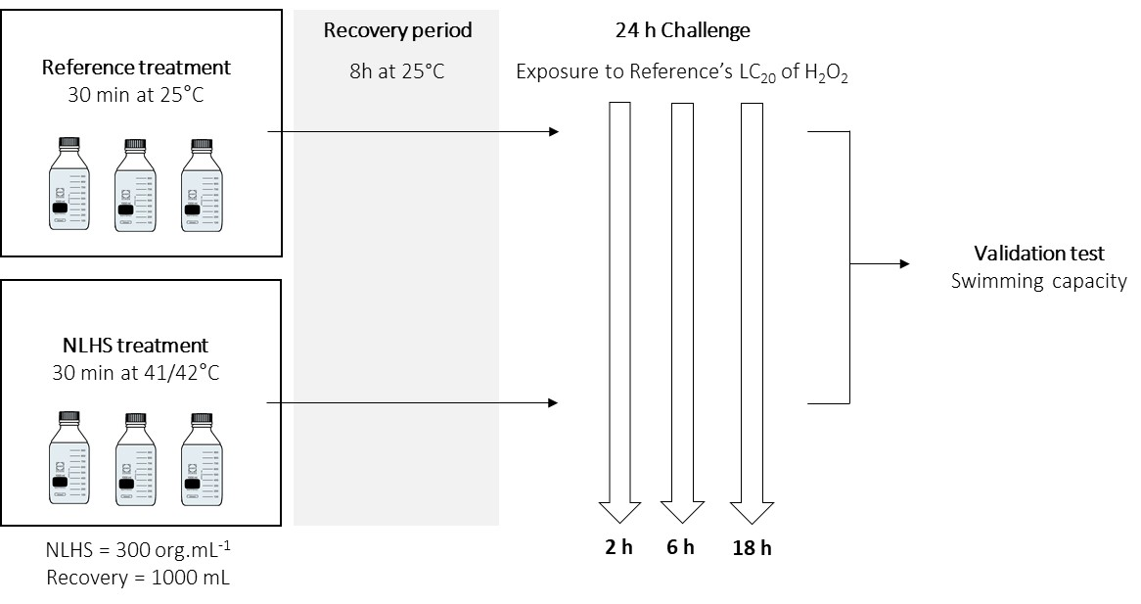

Figure S1 – Experimental design for the non-lethal heat shock-induced cross-tolerance assay and the determination of molecular mechanisms during the exposure to hydrogen peroxide. Organisms were divided into Reference (non-heat shocked) and NLHS (heat shocked) treatments. During the exposure to hydrogen peroxide, organisms were collected for the analyses of differential expression of several genes (general stress and oxidative stress responses and epigenetic modifications), production of HSP70, total acetylation and other modifications of histone H3. After 24 h of exposure, swimming capacity of organisms was assessed to validate the cross-tolerance induction by NLHS. This experiment was performed for two different strains of Brachionus koreanus (MRS10 and IBA3).

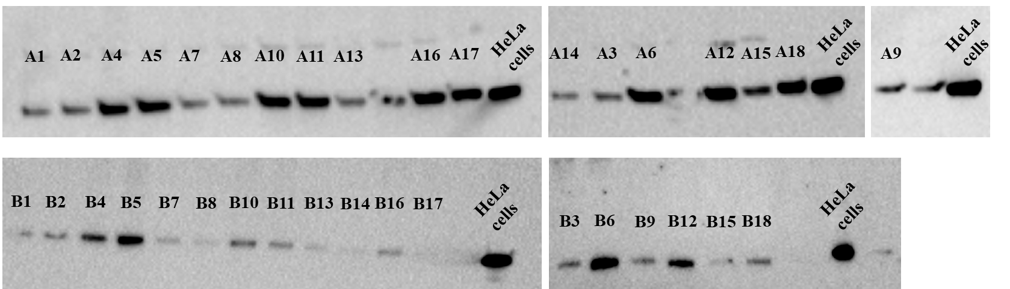

Figure S2 – Protein bands obtained by Western Blot for the relative quantification of HSP70 production level in MRS10 (A) and IBA3 (B) strains of Brachionus koreanus, maintained either at control conditions (Reference – 1-3, 7-9, 13-15) or exposed to a non-lethal heat shock (NLHS – 4-6, 10-12, 16-18), after 2 h (1-6), 6 h (7-12) and 18 h (13-18) of exposure to the Reference’s LC₂₀ of hydrogen peroxide. HeLa (heat shocked) cells was used as technical control and for calculating the relative amount of HSP70 in each sample.

Table S1 – Primer properties for the housekeeping and target genes of rotifers tested in this study: NCBI accession number, primer direction (FW: forward, RV: reverse) and sequence (5'-3'), primer efficiency (%), R squared of standard curve, and primer concentration.

Gene abbreviation | Functional description | Accession | Primer sequences (5’-3’) | Efficiency (%) | r squared | Primer concentration
18S rRNA | 18S ribosomal RNA | KU314660.1 | FW: CCTGCGGCTTAATTTGACT  RV: ACCCACCGAATCAAGAAAG | 92.7 | 0.999 | 1 µM
CAT | Catalase | JX515578 | FW: ACAAGGCAATCCAGTCTATT  RV: AATCGTCCAACAGGTATCAA | 98.2 | 0.991 | 3 µM
MnSOD | Manganese superoxide dismutase | JX000005 | FW: TTGCTTGTTCAAAACATACTC  RV: TAATTGCTTCAGCTAAGTCTCC | 90.5 | 0.999 | 3 µM
GPx | Glutathione peroxidase | KJ526611.1 | FW: TACGGGAAGCAATTATCCTC  RV: GCCAAACTGGTTACAAGGAA | 93.5 | 0.997 | 3 µM
Atg2 | Autophagy-related protein 2 | MH231888 | FW: CCGTAATGGGCTATCAAGTG  RV: TACAGCACCGAACTATTGGC | 96.9 | 0.993 | 3 µM
KMT3E | Lysine N-methyltransferase SMYD3 | MK234818 | FW: CTAAATAGGCTACCTCAGATGC  RV: ATACTGGACACACTTAGATA | 100.2 | 0.999 | 3 µM
KDM1 | Lysine-specific histone demethylase 1A | MK234827 | FW: AAGCAGAGGCGAGTCATTT  RV: CTTCTCTGGGTTGAGGGACT | 100.2 | 0.993 | 3 µM
KAT6 | Lysine acetyltransferase KAT6A | MK234806 | FW: CGAGCCCTTTCTGTTCTACG  RV: TGATACTGCGGCATTACCAT | 99.0 | 0.998 | 3 µM
SIRT6 | Sirtuin 6 | MF945617 | FW: ACATGCAGTCCAACTATCGG  RV: ATCATAAAGGACCCCTCTGC | 105.5 | 0.972 | 5 µM
DNMT2 | DNA methyltransferase 2 | KP898248.1 | FW: TGTGCTCAAGCTGAAGCA  RV: ATCATGTCCCATGTCGTCA | 98.6 | 0.984 | 3 µM

Table S2 – Acute LC₅₀ values determined for MRS10 and IBA3 neonates of Brachionus koreanus, after being exposed to Reference and non-lethal heat shock (NLHS) with subsequent challenges with several stressors. Values were calculated by fitting four-parameter logistic dose-response model (Hill slope – slope of the logistic curve, CI – Confidence Interval, Adj. R² – Adjusted R²). Survival curves of both treatments were compared by global fitting for each stressor, by strain (P ≤ 0.05). Values in bold represent the stressors where NLHS exposure resulted in statistically significant higher tolerance.
MRS10 | Reference |  |  |  | NLHS |  |  |  | Global fitting
 | Hill slope | 24 h LC₅₀ | LC₅₀ - 95% CI | Adj. R² | Hill slope | 24 h LC₅₀ | LC₅₀ - 95% CI | Adj. R² | F (DFn, DFd) | P-value
High salinity  (ppt) | -23.97 | 69.62 | 68.77 – 70.48 | 0.92 | -28.56 | 69.90 | 69.23 – 70.58 | 0.95 | 0.5027 (2,68) | 0.6071
Hydrogen peroxide (mg L⁻¹) | -10.94 | 1.72 | 1.65 – 1.81 | 0.84 | -9.497 | 1.85 | 1.78 – 1.93 | 0.88 | 3.101 (2,68) | 0.0514
Copper sulfate  (mg L⁻¹) | -4.103 | 0.7505 | 0.6697 – 0.8410 | 0.84 | -5.167 | 0.8654 | 0.8098 – 0.9248 | 0.94 | 2.999 (2,68) | 0.0565
Cadmium chloride (mg L⁻¹) | -4.941 | 123.2 | 112.4 – 135.0 | 0.92 | -3.266 | 160.3 | 145.0 – 177.1 | 0.92 | 8.342 (2,68) | 0.0006
IBA3 | Reference |  |  |  | NLHS |  |  |  | Global fitting
 | Hill slope | 24 h LC₅₀ | LC₅₀ - 95% CI | Adj. R² | Hill slope | 24 h LC₅₀ | LC₅₀ - 95% CI | Adj. R² | F (DFn, DFd) | P-value
High salinity  (ppt) | -21.56 | 67.84 | 66.96 – 68.73 | 0.92 | -25.97 | 69.40 | 68.51 – 70.30 | 0.91 | 3.412 (2,68) | 0.0387
Hydrogen peroxide (mg L⁻¹) | -12.11 | 1.39 | 1.35 – 1.43 | 0.91 | -7.578 | 1.57 | 1.51 – 1.62 | 0.91 | 16.36 (2,68) | <0.0001
Copper sulfate  (mg L⁻¹) | -4.420 | 1.551 | 1.419 – 1.696 | 0.88 | -3.469 | 1.622 | 1.480 – 1.778 | 0.88 | 0.7830 (2,68) | 0.4611
Cadmium chloride (mg L⁻¹) | -6.110 | 269.7 | 247.9 – 293.5 | 0.93 | -4.949 | 342.5 | 318.6 – 368.2 | 0.91 | 12.50 (2,68 | <0.0001

Table S3 – Discrimination of behaviour (average ± SD) of reference (maintained at control conditions) and non-lethal heat shocked (NLHS) MRS10 and IBA3 rotifers (Brachionus koreanus) after exposure for 24 h to the Reference’s LC₂₀ of hydrogen peroxide for validation of scale-up cross-tolerance tests. The individuals were classified as swimming, adhesive (active but not swimming), and inactive (presumably dead).

 | Reference | NLHS
MRS10
Swimming (%) | 61.67 ± 16.02 | 85.83 ± 11.14
Adhesive (%) | 38.33 ± 16.02 | 14.17 ± 11.14
Inactive (%) | 3.33 ± 8.16 | 6.67 ± 10.32
IBA3
Swimming (%) | 18.33 ± 15.71 | 31.67 ± 23.80
Adhesive (%) | 81.67 ± 15.71 | 68.33 ± 23.80
Inactive (%) | 23.33 ± 23.38 | 6.67 ± 10.33

